**Outlier Detection Code Documentation**

1. **XXX_currency.R**

* **Usage:**
  + Search for the possible outlier dates for the currency.
* **Input:**
  + csv file contains the date and the rates of each tenor

Sample:



* **Output:**
  + CSV file named “XXX_currency_outlier.csv”, which contains a new indicator column. 1 means possible outlier day.

Sample:



* + Plot for outliers for each tenor in JPEG format

Sample:

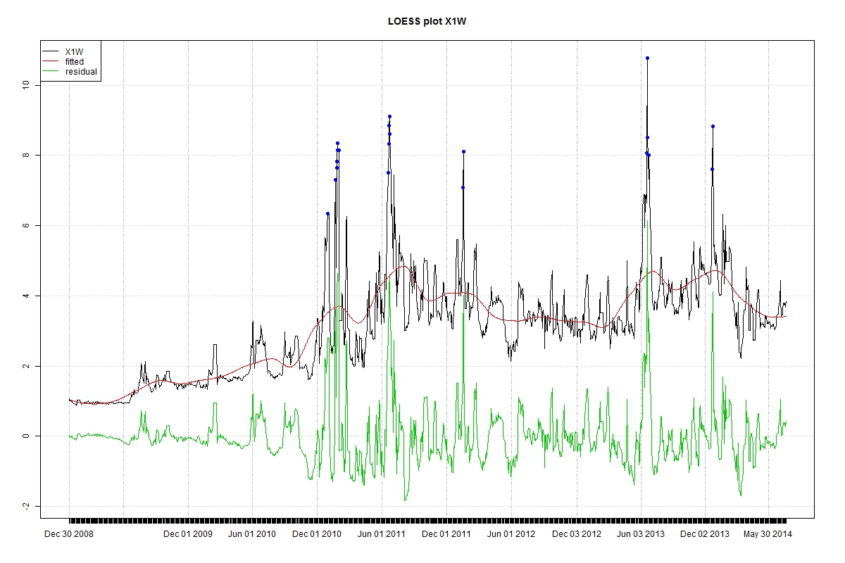

* + Plot for all tenors and possible outlier dates in JPEG:

Sample:

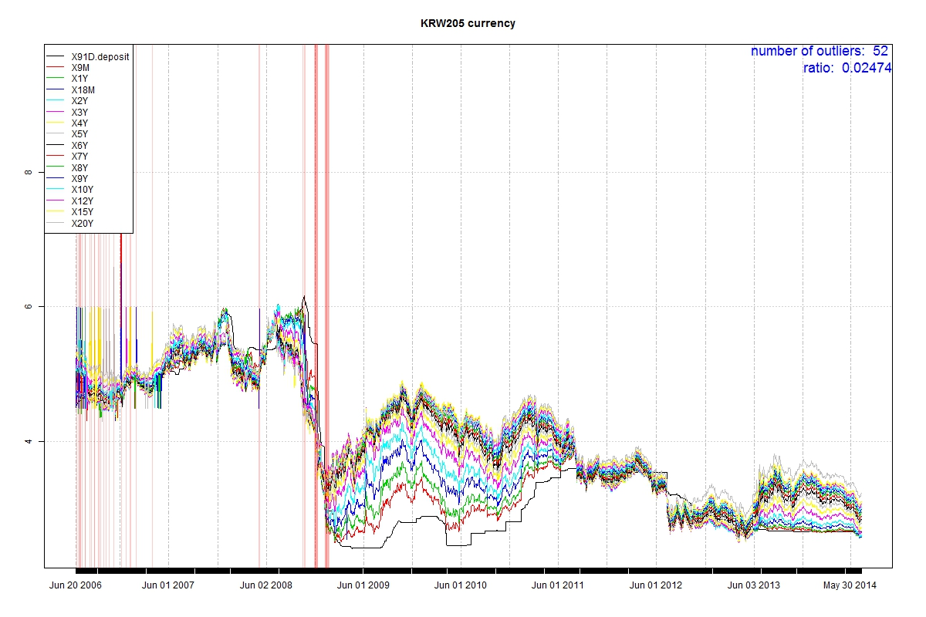

* + Plot for checking specific tenor in each possible outlier date in JPEG:

Sample:

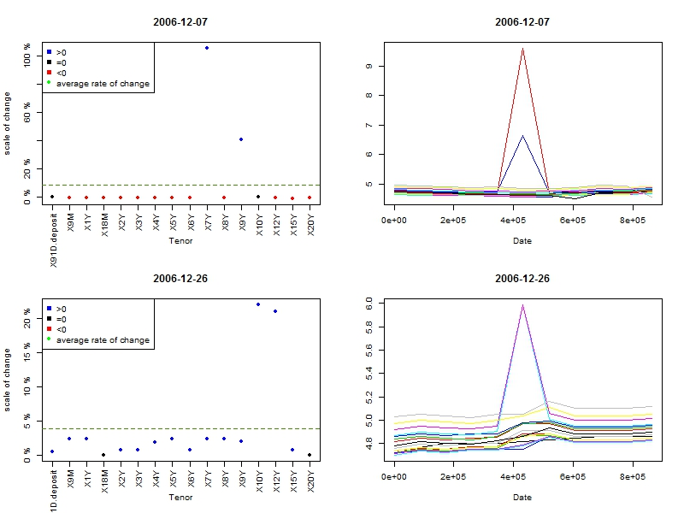

1. **XXX_currency_interpolation.R**

* **Usage:**
  + Interpolate the value for the outlier tenors on specific dates
* **Input:**
  + CSV file contains an indicator matrix

Sample:



* **Output:**
  + CSV file named “XXX_currency_result_table.csv”, which contains a table for the interpolation result

Sample:



* + CSV file named “XXX_currency_interpolated.csv”, which replaces the interpolated value.